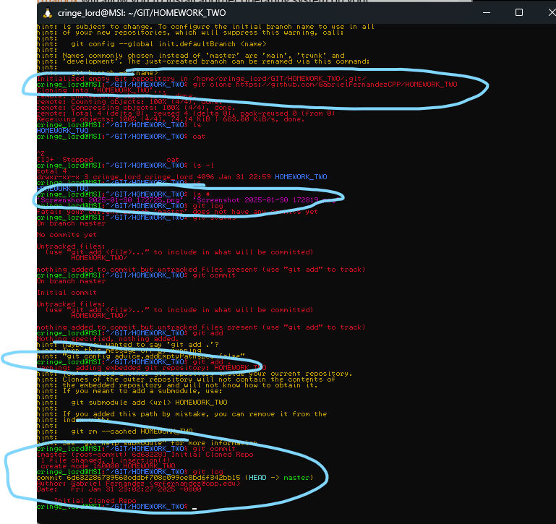

The circled ones are the major results. I’m currently using WSL with Ubuntu.